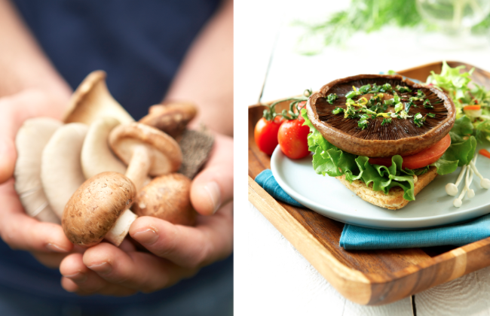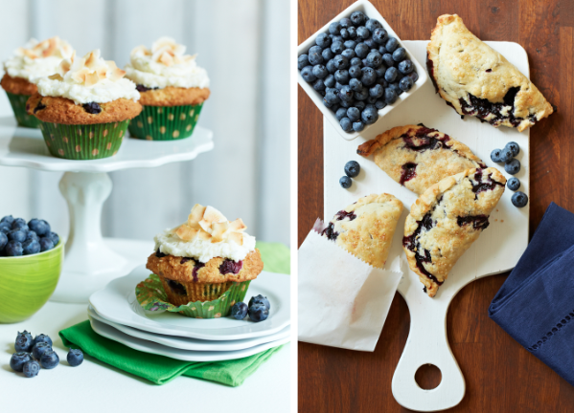

1.) Look at various food magazines and research food photography tips and techniques.

2.) Research lighting techniques from food stylists.

3.) Take a series of photos and create a menu using word showcasing and advertising the establishment of your choice or your own recipes.

4.) Images should be edited using Photoshop, VSCO app or Pic-monkey.

5.) Images presented to class when completed.

Identify skills developed through the study of visual arts that can be transferred to a variety of careers.

Food Photography

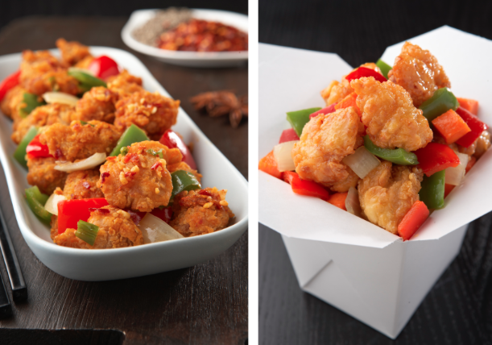

Resources/ Examples:

<http://digital-photography-school.com/food-photography-techniques-and-tips>

<http://www.picturecorrect.com/tips/food-photography-tips-and-techniques/>

http://blog.photoshelter.com/2013/05/back-to-basics-food-photography-lighting-styling/

10- Assignment

10- Elements & Design

10- Effort

10-Craftsmanship

10-Participation

Total- 50 marks

Assessment

Due Date:

[Street Address]  
[City], [State][Postal Code]

[Web Address]

Lorem Ipsum

# Assessment Rubric

50 marks Total/ Each Section out of 10

Excellent Good Average Below Average

|  |  |  |  |  |
| --- | --- | --- | --- | --- |
| Assignment | Turned in required # of Photos.  All images clearly represent assignment focus. | Turned in (less than) required # of photographs.  Images mostly represent assignment focus. | Turned in half of required photographs.  Images somewhat represent assignment focus. | Turned in less than half of required photograph.  Images barely represent assignment focus. |
| Elements +  Desgin | Strong evidence of consideration of principles and elements.  Displayed a clear effort in decision making | Some evidence of consideration of principles and elements.  Displayed a decent clear effort in decision making | Few evidence of consideration of principles and elements.  Displayed some decent clear effort in decision making | Hardly any evidence of consideration of principles and elements.  Displayed little effort in decision making |
| Effort | Participated in all group discussions and critques. Displayed a clear effort to experiement and express oneself in the images. | Participated in most group discussions and critques. Displayed a mostly good effort to experiement and express oneself in the images. | Participated in some group discussions and critques.  Displayed some effort to experiement and express oneself in the images. | No class participation.  Expressed no effort inside or outside of class. |
| Craftsmanship | Perfect in focus- no shakiness or blur. | Mostly in focus- some shakiness or blur | Somewhat in focus- lots of shakiness or blur | Barely in focus- mostly shaky and blurry. |
| Participation | Worked efficiently during all classes. | Worked fairly well during class-time. | Worked with some distraction or disruption. | Barely worked during class time. |