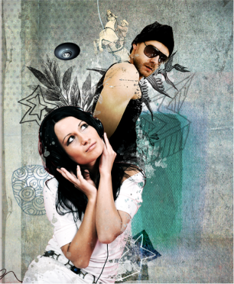
Assignment: Create a hybrid self-portrait that includes a photograph of you and captures your style. Your piece must include scanned elements of drawings, text or doodles that connect to you. You may also scan and layer other images and objects to add texture and detail. Plan out how your image will be arranged using the elements and principles of design.
Your image must also include layers of masks and textures. The style of your portrait image is up to you!
Mixed Media: A technique involving the use of two or more artistic media, such as
photography and pencil, ink and pastel, or painting and collage, that are combined.

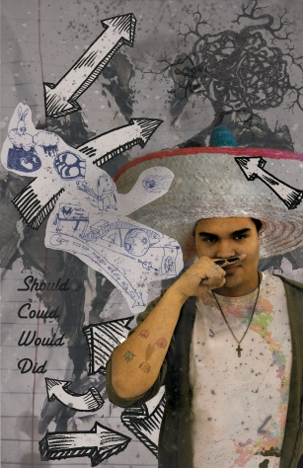
Hybrid: Combining two or more different elements
Technical Aspects of the Assignment: Layer Masks, Textures in Photoshop, Blending Modes, Scanning, Photography.

In your sketchbook….
RESEARCH
- Choose an artist from the art history presentation and decide on a portrait work to analyze. (If you would like to look at another artist’s work, please first have it approved by your teacher.) Answer the questions on the handout about your chosen artwork and post to your blog alongside an image of the work.
- Look for images of portraits created by other artists. Select a minimum of THREE that you like and print and glue them into your sketchbook. Write beside them what it is you like about them and what elements you may wish to include in your own project. (You Tube)
- Decide what style of portrait you want to create (scary, dark, humorous, silly, etc.)
- Do some planning sketches for your final design
- Plan how you will EMPHASIZE yourself in your composition
CREATE!
Once you have a final design plan, begin gathering the images and photographs you will need to execute your design. Try to use as many of your own original photos as you can! (If using any images found online, ensure that they are license-free!) Experiment with scanning in your own drawings and/or text, adding texture, layer masks, and blending modes. You may also wish to have a photoshoot with a classmate to get an image of yourself to incorporate.

REFLECT & PRESENT
Complete the artist statement handout and add to your online portfolio.
