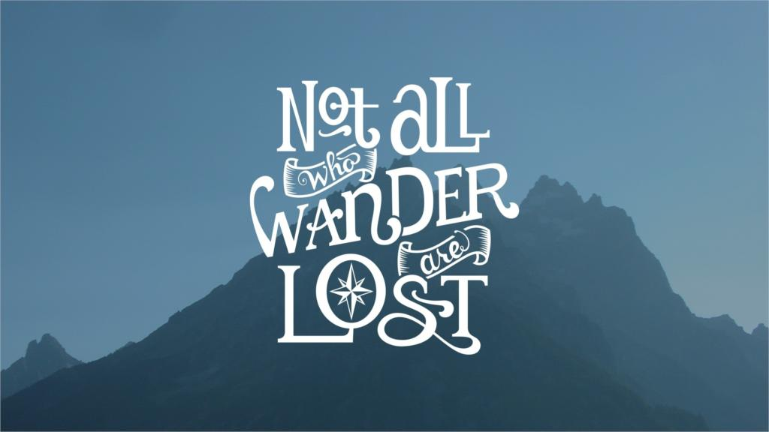
Assignment #3
Demonstrate what you have been learning about typography by creating a poster where the text is the artwork. You will create your text design in Adobe Illustrator and then transfer to Photoshop to complete the overall effect.

Instructions:
- Brainstorm quotes that you may want to use for your poster.
Consider the following…
- Do I want an inspirational quote? A quote that is humorous, ironic, literary, historical, or attributed to someone famous?
- What images, emotions, or colours come to mind when I think about this quote?

- Complete preliminary work in your sketchbook, including mind maps, lists, sketches, printed examples of typography, colour scheme ideas, etc. You must complete a final layout plan and have it approved by your teacher.

- Open a file in Illustrator with the following information: Name: ‘Last name- Quote poster” Size: 11 x 17 inches (or 17 x 11) Resolution: 300 ppi Colour Mode: CMYK.

- Experiment with tools such as type on a path, brush tools, gradients, swatches, and manipulating text by using anchor points. You may also want to download license-free fonts from sites such as Google Fonts.

- Ensure that your final design is readable, legible, balanced, has emphasis, is visually interesting, and captures the feeling or meaning behind the quote.

- Post to your TEAMS account along with a separate file for your artist statement/story (refer to handout).

Assigned Date:
Due Date:
REPORT THIS AD
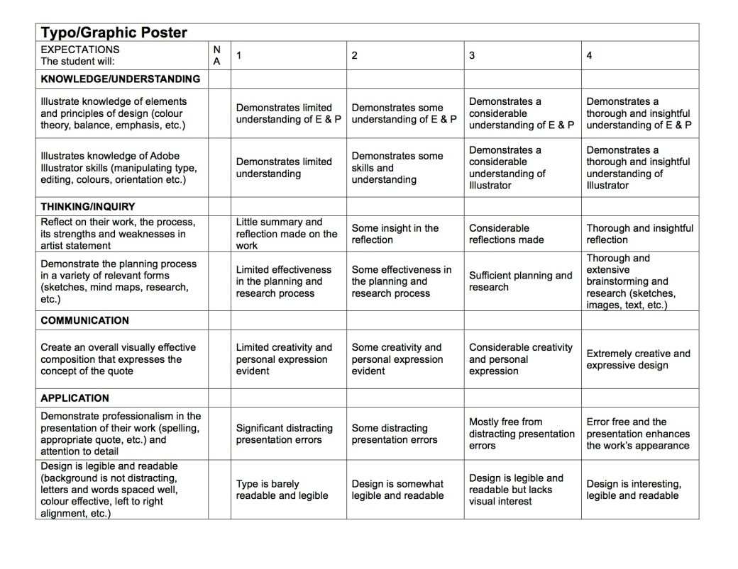
Poster Score. /40

